William Skinner
Pro390

Status report W8

- 1-2 screenshots of your project progress.
  - 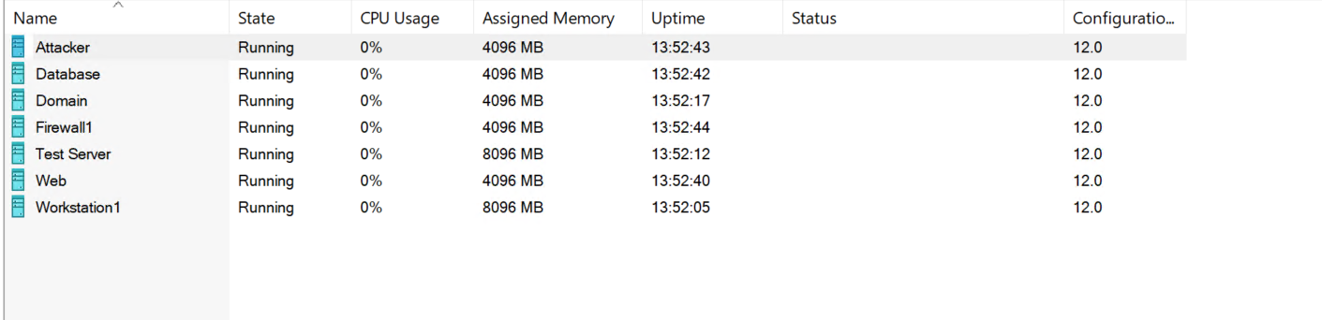
  - 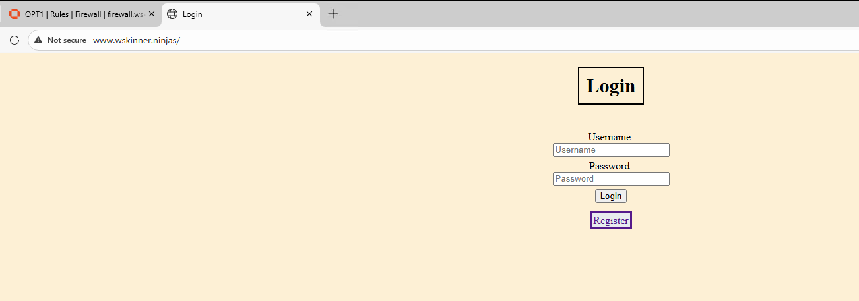
- A screenshot your GitHub activity from the past 2 days.
  - 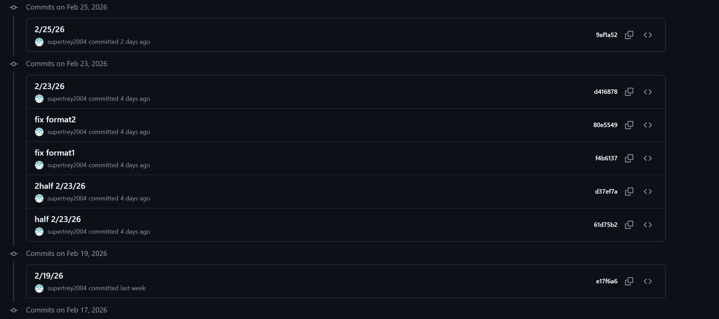
- Output from the git commands
  - 